**Table Structure for Children Health Report Application**

|  |  |
| --- | --- |
| Table Number | Table Names |
| 1.  2.  3.  4  5.  6.  7. | CHILD  PARENT  CHILDPARENTDETAILS  VACCINEMASTER  DOCTORMASTER  CLINICMASTER  CHILDHEALTHREPORT |

1. CHILD

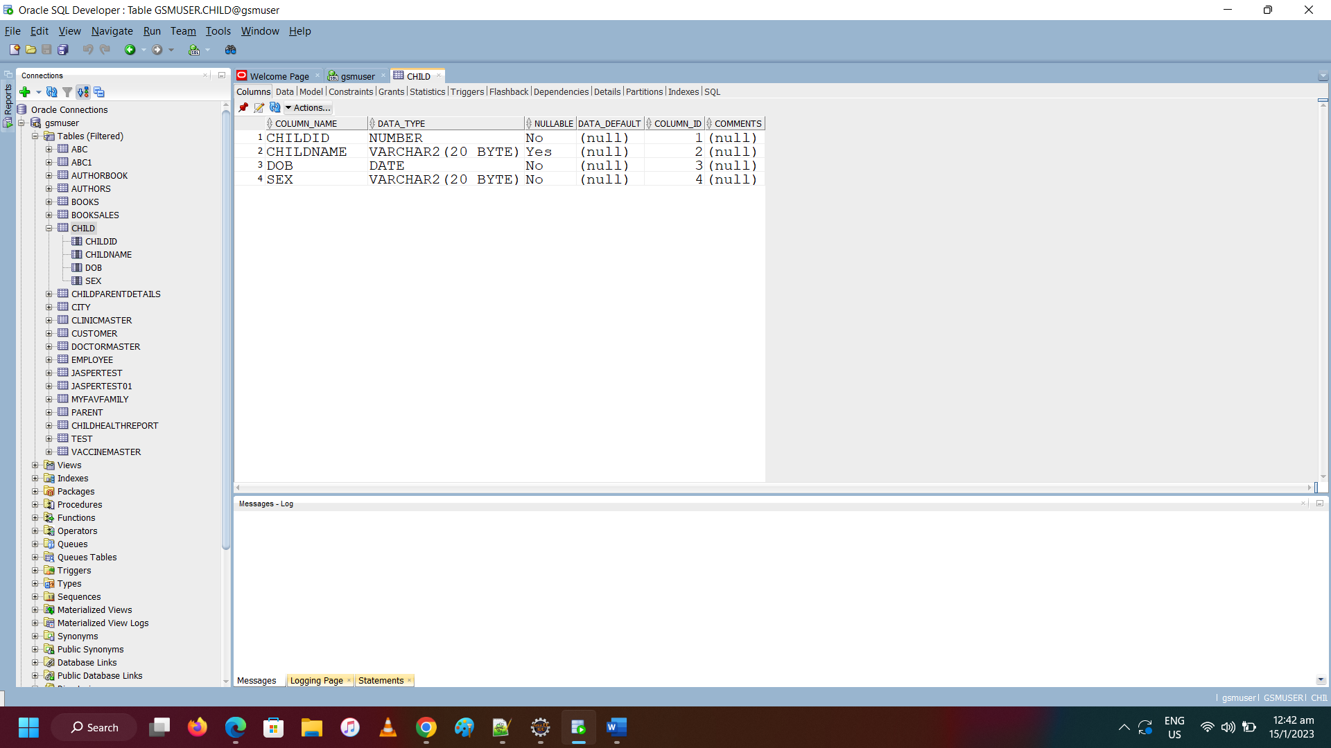

2. PARENT

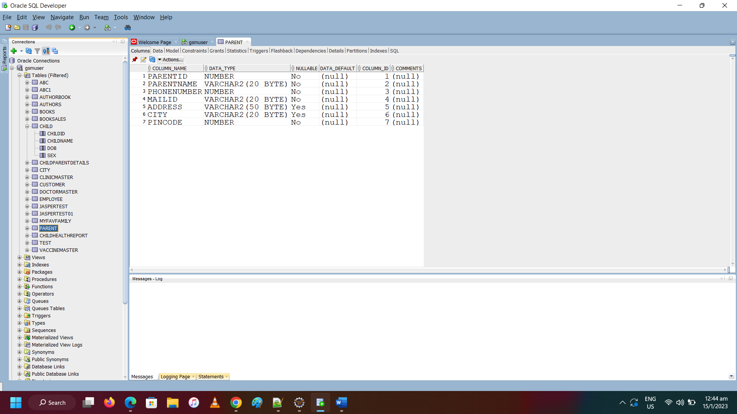

3. CHILDPARENTDETAILS

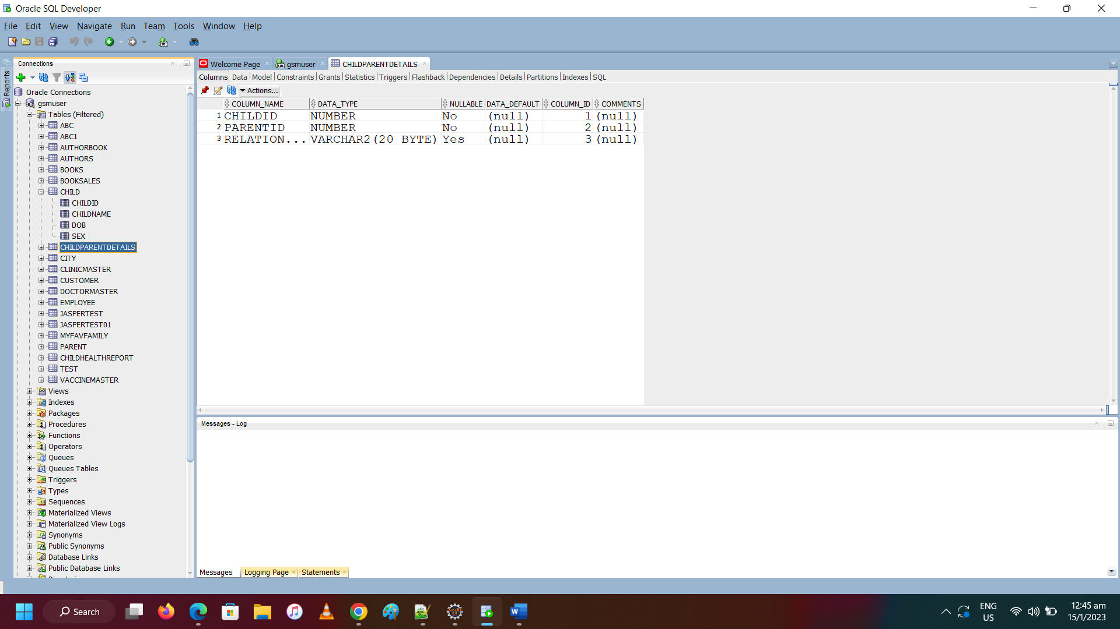

4. VACCINEMASTER

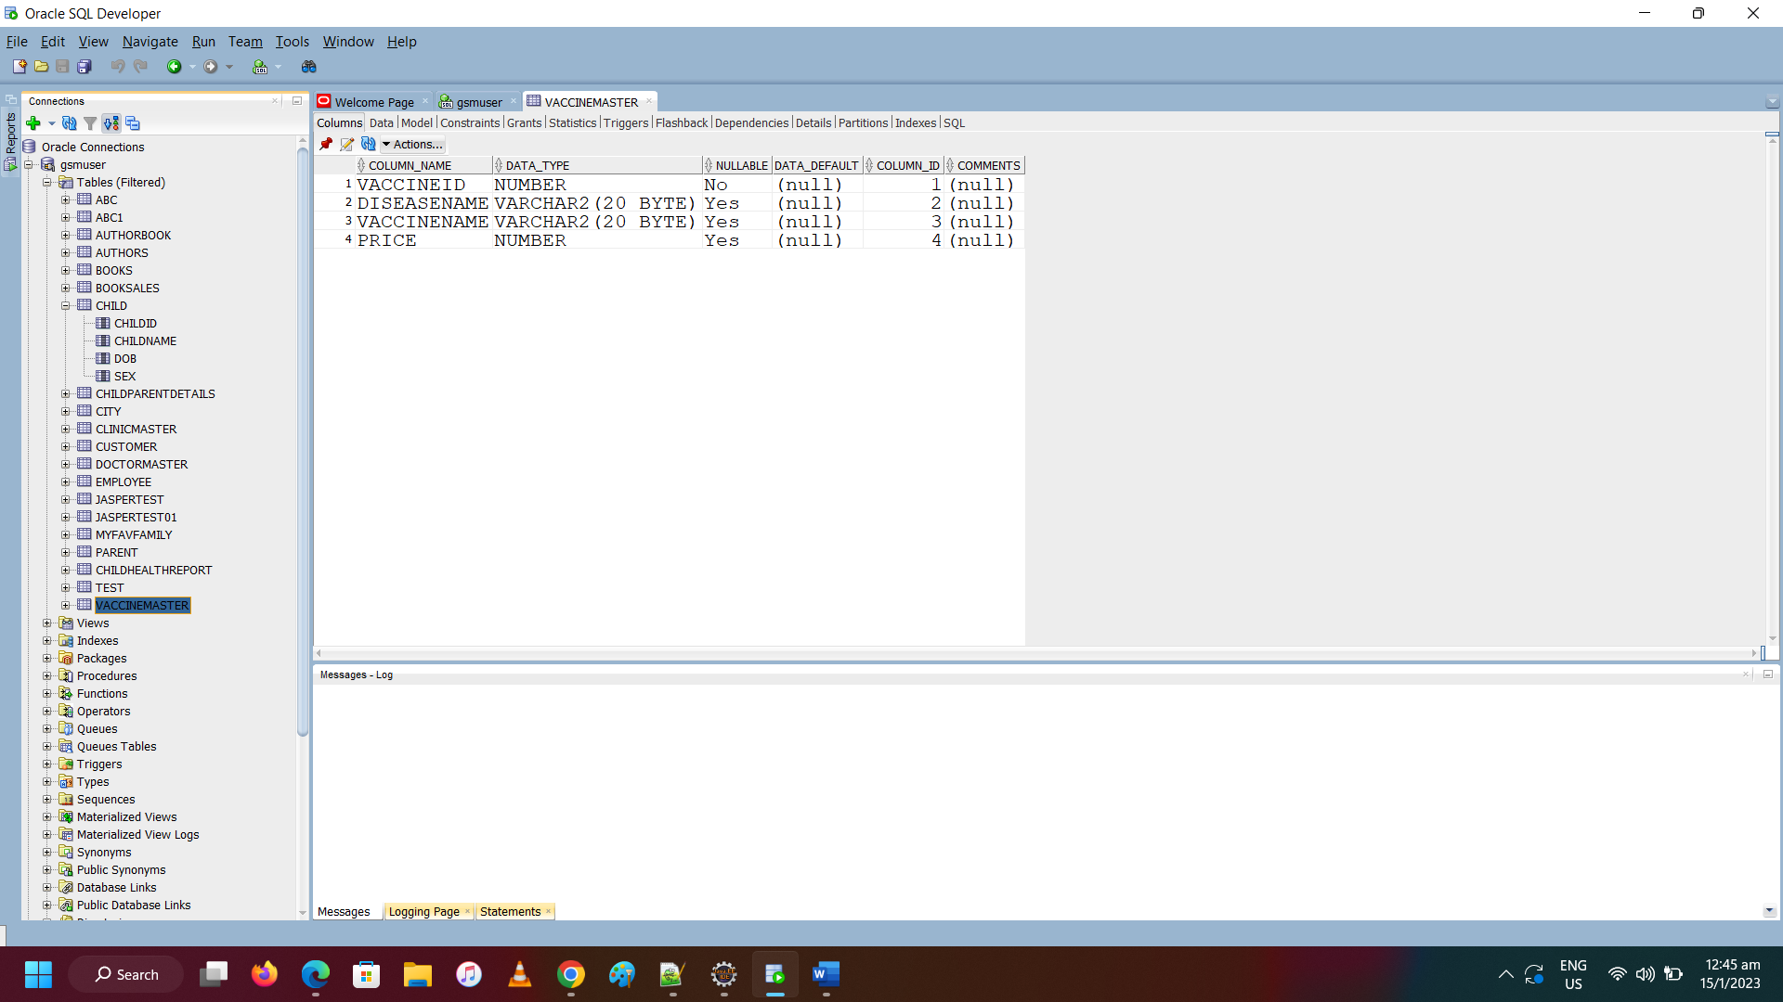

5. DOCTORMASTER

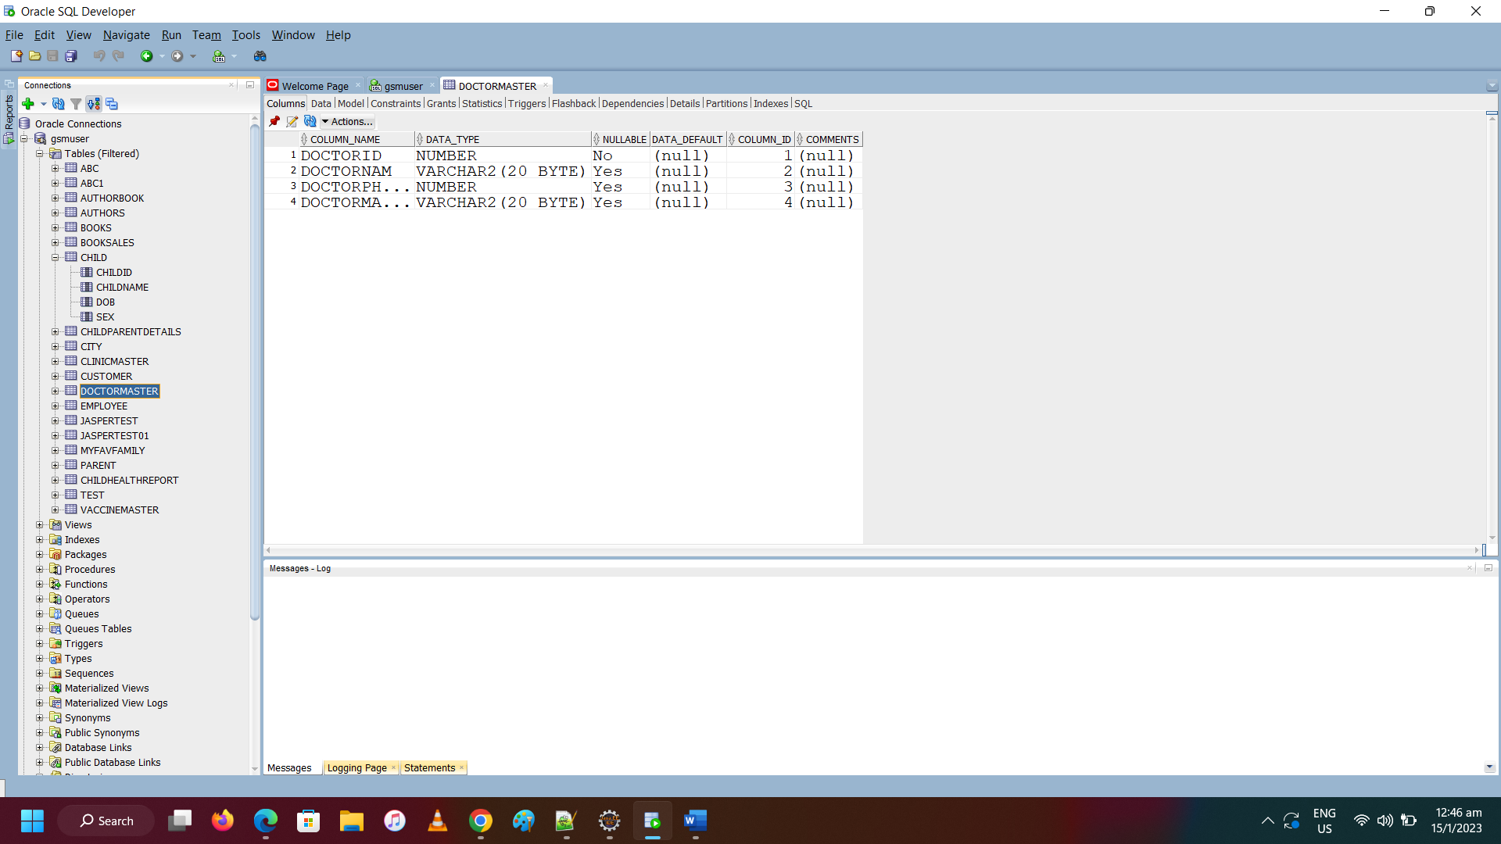

6. CLINICMASTER

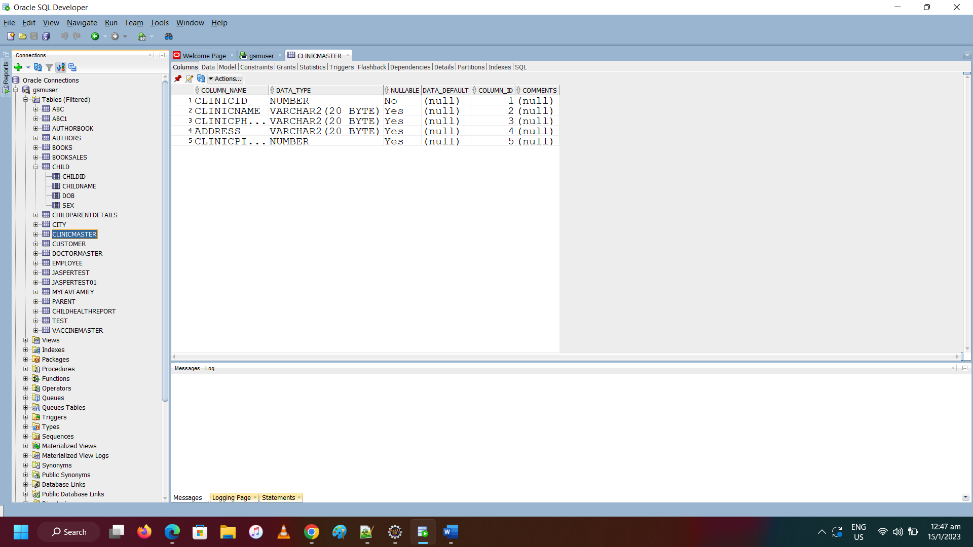

7. CHILDHEALTHREPORT

